**SIGN LANGUAGE RECOGNITION SYSTEM BASED ON COMPUTER VISION**

*A Graduate Project Report submitted to Manipal University in partial fulfilment of the requirement for the award of the degree of*

**BACHELOR OF TECHNOLOGY**

**In**

**Electronics and Communication Engineering**

*Submitted by*

|  |  |  |
| --- | --- | --- |
| **Suraj Pai**  Reg. No:120907042  Section: C  Roll No.: 9 | **Deepthi Varambally**  Reg. No:120907580  Section: C  Roll No.: 45 | **Pritika Kohli**  Reg. No:120907558  Section: C  Roll No.: 43 |

*Under the guidance of*

**Prof T.K. Padma Shri (Internal)**

**Associate Professor- Senior Scale**

**Department of Electronics and Communication**



**DEPARTMENT OF ELECTRONICS AND COMMUNICATION ENGINEERING**

**MANIPAL INSTITUTE OF TECHNOLOGY**

(A Constituent College of Manipal University)

MANIPAL – 576104, KARNATAKA, INDIA

**MAY 2016**

**DEPARTMENT OF ELECTRONICS AND COMMUNICATION ENGINEERING**

**MANIPAL INSTITUTE OF TECHNOLOGY**

(A Constituent College of Manipal University)

MANIPAL – 576 104 (KARNATAKA), INDIA

Manipal

< Date >

**CERTIFICATE**

This is to certify that the project titled **SIGN LANGUAGE RECOGNITION SYSTEM BASED ON COMPUTER VISION** is a record of the bonafide work done by **SURAJ PAI** (*Reg. No. 120907042*) , **DEEPTHI VARAMBALLY** (*Reg. No. 120907580*), **PRITIKA KOHLI** (*Reg. No. 120907558*) submitted in partial fulfilment of the requirements for the award of the Degree of Bachelor of Engineering (BE) in **ELECTRONICS AND COMMUNICATION ENGINEERING** of Manipal Institute of Technology Manipal, Karnataka, (A Constituent College of Manipal University), during the academic year 2015-2016.

|  |  |
| --- | --- |
| **Prof.T.K. Padma Shri**  **Associate Professor-Senior Scale**  **Department of Electronics and Communication**  *Project Guide* | **Prof. Dr. Somashekara Bhat**  *HOD, E & C.*  *M.I.T, MANIPAL* |

**ACKNOWLEDGMENTS**

This section should contain the acknowledgements due to the Director, Dept HOD, Project supervisor, company personnel, department guide, Laboratory Incharge (where the work was carried out) and faculty members whose assistance was sought during the project work.

**ABSTRACT**

Indian Sign Language (ISL) is a visuospatial language involving the use of hands, arms, facial expressions, and head/body postures to encode linguistic information. 98% of the deaf community in India is ISL illiterate and rely on inconsistent oralist methods of education. The advent of Science and Technology has been highly successful in aiding the design of solutions to emerging world problems. Our proposed work aims to employ available technology with customized software to recognize 3D dynamic signs to realize a distinctive description of a gesture. With this identified gestural code, the system can use artificial intelligence to predict the sign and convert it to text or speech as necessary. A plethora of finger positions, joint orientations and trajectory information are made tractable with the development of 3D sensors like Microsoft Kinect. Our novel method classifies 3 gestures using Kinect for Windows (Global Feature Extraction) with the onboard RGB and Depth sensor cameras.

Several methods for optimal classification have been implemented in this study. An initial collection of extensively varying training data over 3 gestures gave us 170 samples to work with. Post data collection, the joints co-ordinates were mapped corresponding to their 3 dimensional locations. To make a baseline/ comparative analysis, the gesture skeleton was constructed and binarized along with normalization. This was used for preliminary training and performance evaluation of our system. In the next phase, joint co-ordinate data obtained from the skeletal images of the captured gesture operated with statistical parameters such as mean, variance, kurtosis and skewness; and the joint values are all separately fed into a network classifier following a common neural network training method of error back propagation with several algorithm implementations such as gradient descent, moment, scaled conjugate etc. The joint co-ordinate data is also provided to a support vector machine to have a large margin classification of the classes.

From the above described methods, the first benchmark was using binary images with various machine learning system models.( Learning algorithms used: Gradient Descent(with adaptive momentum, with adaptive learning rate);Levenberg Marquardt, Scaled Conjugate Gradient). The single metric used for comparison was classification error on the validation set. Confusion plots were used for broader comparison considering two metrics- recall, fall-out. ROC plots were also used for accurate depiction of results. With binary data, the best classification was obtained for Gradient Descent with Adaptive learning rate with 93.9% average classification accuracy( over training, validation and test sets). Gesture co-ordinate data with a higher resolution provided much higher average classification accuracy. Optimizations were run over model selection, regularization parameter, hidden layers and number of neuron units with the validation data to select the best model. SVM model was also used to provide an insight into large margin classification of the same data.

The intended study gave us an insight into optimization methods, large data collection and plotting the results in the most decisive manner. An overall trial suggested that gesture code with high resolution provided the best classification with Adaptive learning rate gradient descent. For gesture-image capturing, we used the Microsoft Kinect and for the software domain, MATLAB was used for image processing, statistics and machine learning.

**LIST OF TABLES**

|  |  |  |
| --- | --- | --- |
| **Table No** | **Table Title** | **Page No** |
|  |  |  |
|  |  |  |
|  |  |  |
|  |  |  |
|  |  |  |
|  |  |  |

**LIST OF FIGURES**

|  |  |  |
| --- | --- | --- |
| **Figure No** | **Figure Title** | **Page No** |
|  |  |  |
|  |  |  |
|  |  |  |
|  |  |  |
|  |  |  |
|  |  |  |

|  |  |  |  |  |  |
| --- | --- | --- | --- | --- | --- |
| **Contents** | | | | | |
|  | | | | | Page No |
| Acknowledgement | | | |  | i |
| Abstract | | | |  | ii |
| List Of Figures | | | |  | iii |
| List Of Tables | | | |  | vi |
|  | | | | | |
| **Chapter 1** | | | **INTRODUCTION** | |  |
|  | **1.1** | Introduction | | |  |
|  | **1.2** | Motivation | | |  |
|  | **1.3** | Organization of Report | | |  |
|  | | | | | |
| **Chapter 2** | | | BACKGROUND THEORY and/or LITERATURE REVIEW | |  |
|  | **2.1** |  | | |  |
|  | **2.2** |  | | |  |
|  | | | | | |
| **Chapter 3** | | | **METHODOLOGY** | |  |
|  | **3.1** |  | | |  |
|  | **3.2** |  | | |  |
|  | | | | | |
| **Chapter 4** | | | **RESULT ANALYSIS** | |  |
|  | **4.1** |  | | |  |
|  | **4.2** |  | | |  |
|  | | | | | |
| **Chapter 5** | | | **CONCLUSION AND FUTURE SCOPE** | |  |
|  | **5.1** | Work Conclusion | | |  |
|  | **5.2** | Future Scope of Work | | |  |
|  | | | | | |
| **REFERENCES** | | | | |  |
| **ANNEXURES (OPTIONAL)** | | | | |  |
| **PROJECT DETAILS** | | | | |  |

**CHAPTER 1**

**INTRODUCTION**

This chapter contains a description of the hardware used and its application in different fields of computer vision. A present day scenario of how the Kinect hardware is used is described. The chapter then delves into the field of Sign Language Recognition and Computer Vision along with previous papers that have established pillars in these fields. The motivation behind this project along with the main and secondary objectives is clearly highlighted. The project timeline and updates is also mentioned.

**1.1 INTRODUCTION TO KINECT HARDWARE**

The Microsoft Kinect launched in November 2010, it was a targeted gaming controller for the Xbox 360 Gaming Console [1]. The device provides a controller free experience using computer vision techniques. The device is a combination of a RGB Camera, Depth Sensor and Microphone array. This caught attention in the developer community who wanted to repurpose the device to use it for specific computer vision projects as it was easily available and low cost at the time of release. Open source software was released unofficially followed by official support from Microsoft for Developers along with support libraries. It is able to track a user’s full body and provides framework for building sign language related applications.

The Microsoft Kinect has been used for a plethora of industry changing and out-of-the box gaming technology such as Kinect Sports, Kinect Fitness, Dance Central ,etc. that brought the convenience of all these facilities direct to your home. It has gone beyond just commercial applications as developers have adapted the device for various systems such as detecting human fall by measuring velocity, upper limb rehabilitation for people suffering from cerebral palsy, accessible design for the colour blind and games for children with cognitive disabilities.

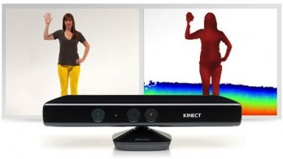

Figure 1: A generic Kinect System

**1.2 PRESENT DAY SCENARIO IN SIGN LANGUAGE RECOGNITION AND COMPUTER VISION**

Sign language detection is generally done with one of two methods. These are either wearable assisted gesture recognition or computer vision methods. Computer Vision is a discipline that includes methods for acquiring, processing, analysing, and understanding images and, in general data to provide data or numerical information. Sign language wearables provide higher accuracy and better data to work with but are more of a hindrance than computer vision techniques that require bare minimum requirements from the user. In this decade, a lot of projects and research have been initiated with wearables. Sign Aloud, a wearable glove that leverages the power of motion detection embedded with a speech processor; works as a gesture to speech translator. Developed by students from University of Washington it is a system in development but with highly promising demos and test launches. Another system that was developed used electromyography to diagnose muscle movement and react accordingly with speech output corresponding to the sign gesture.

In the field of computer vision, a few novel solutions have been designed by various researchers. An array of camera combinations including Time of Flight cameras, RGB cameras, grayscale cameras have been used. Most of the research has been inclined toward ASL, BSL and sign language dialects from around the world. The degree of research in ISL has been very primitive (There are no open access ISL datasets available). A few papers have taken ISL into consideration and developed novel systems. A research study from Amrita School of Engineering has used feature extraction methods such as ALI and PCA to pioneer their work. There have been very few research studies that have combined insight into ISL with Artificial Intelligence.

**1.3 MOTIVATION**

Sign language is a gestural code representing the surrounding spoken language with varied features. These sign languages are complex natural languages and a part of the Deaf culture at all levels. Sign languages have various variants across the world. Our motive is to facilitate ISL words and capture them on Kinect sensors, thereby recognizing the dynamic ISL gestures. Previous research and projects have not delved into ISL along with effective use of Neural Networks/SVMs. With advancement in Machine Learning and computing capabilities, a dedicated system can be trained and tested for offline learning to identify gesture feature inputs.

The approach uses Kinect based global features for recognition making it a fine-grain description of a gesture. These features are statistically analysed and dimensionality reduction procedures are used. The features are then fed to a neural network that is later optimized to provide the most accurate classification. This system finds a variety of applications in:

* A brilliant application in the field of Computer Vision
* Widely used in Schools, Hospitals and Government agencies as a language interpreter
* An important tool in professional courses and associate programmes/degrees on Sign language.
* Sign language recognition systems are used in significant events like presidential speeches, courtroom affairs and office-work/conferences.

A positive end result would provide for a system that can classify a particular 3D gesture into a spoken phrase without human intervention or manual input at any stage.

**1.4 OBJECTIVE**

Primary objective of the research is to design a system that can classify 3 gestures captured using Kinect for Windows and display either text or speech outputs. The system must have a training efficiency of more than 95% and a validation accuracy of above 85%. A net accuracy of above 90% classification is aimed at. The secondary objective would include gaining an insight into optimization procedures involved in Neural Networks and SVMs along with performance metrics used in these cases.

**1.5 TARGET SPECIFICATIONS**

Achievement of the primary as well as secondary objective would provide for a system that is stably built on the foundation of neural networks and large margin classifiers that can successfully classify a gesture into one of the three output classes. This system could find widespread use in schools where the hearing impaired generally require an interpreter for translation. It can find use in gatherings where the audience belongs to the hearing impaired community and needs to effectively communicate without third party intervention. It can be reverse engineered to learn sign language based on the training gestures provided.

**1.6 PROJECT SCHEDULE**

|  |  |
| --- | --- |
| *January 2015* | * Collection of training data * Feature extraction for obtaining Global Features * Variation of subsequent data sets and data accumulation * Logging of methods and procedures used |
| *February 2015* | * Algorithm implementation for obtaining final input data to feed to the network * Design of the neural network (EBPTA) for classification using binary data * Comparison of different algorithms with EBPTA for better classification results. |
| *March 2015* | * Experimentation with Neural Networks to identify best network for classification with the use of gesture co-ordinate data. * Variation of training data along with activation function to obtain best specificity and sensitivity results. |
| *April 2015* | * Finalization of neural network to be used and optimization processes. * Design of SVM to classify the gestures. |
| *May 2015* | * Optimization of SVMs * Documentation process. |

Table 1: Project Timeline

**1.7 ORGANIZATION OF THE REPORT**

Chapter 1 introduces the domain of sign language along with the hardware used (Microsoft Kinect). Chapter 2 describes the basics of image acquisition and relevant survey conducted in this field regarding the awareness and general statistics of physical features of the general population. It discusses the basic algorithm of pre-processing and neural networks. Chapter 3 describes the method incorporated for our project. It explains about binarization, Statistical analysis of gesture data incorporated with error back propagation and its different techniques. Chapter 4 deals with the result analysis by comparing the different techniques of classification. Chapter 5 is the conclusion of the result by comparing the different techniques of gesture classification.

**CHAPTER 2**

**BACKGROUND THEORY**

This chapter includes a Literature review that describes related papers and projects in the field of research. It gives a broader perspective on methods and algorithms used in these papers and analysis of the results obtained. This section also includes theoretical discussion and mathematical intuition of algorithms and formulas used in our research to provide the reader a strong background to review the future chapters.

**2.1 LITERATURE REVIEW**

Some of the notable works involved glove based recognition; the ﬁrst category requires signers to wear a sensor glove or a coloured glove. The wearing of the glove simpliﬁes the task of segmentation during processing. Glove based methods suffer from drawbacks such as the signer has to wear the sensor hardware along with the glove during the operation of the system. In comparison, vision based systems use image processing algorithms to detect and track hand signs as well as facial expressions of the signer, which is easier to the signer without wearing gloves. The vision-based technique has seen innumerable approaches for recognition such as the conventional object –based video abstraction technique. Another technique involves the Hidden Markov Model where states are defined with probabilistic theories and have developed an unsupervised approach to train a robust detector the presence of human hands within an image and classified the hand shape [2]. One paper has described the usage of template matching with normalized cross-correlation along with two wrist bands to identify and extract the gesture [3]. A couple of other papers address the wavelet transformation applied to gesture images for Finger-Earth Mover’s Distance (FEMD) which is a novel shape distance metric was used in its gesture recognition process [4]. Though all the above algorithm techniques were suitable and achieved classification of about 70-99%, it involved a lot of background noise removal in the pre-processing stage or has proved to be cumbersome when the classification extended to an acquired data of heavy amounts.

Our work and ideas were majorly influenced by a paper on “A Vision Based Dynamic Gesture Recognition of Indian Sign Language on Kinect based Depth Images”. This method integrates both local as well as global information of the dynamic sign. A trajectory based feature extraction method using the concept of Axis of Least Inertia (ALI) was proposed for global feature extraction. An Eigen distance based method using the seven 3D key points extracted using Kinect is proposed for local feature extraction. Integrating 3D local features improved the performance of the system as well [5]. The system is suitable for complex ISL dynamic signs. However, the gesture recognizer wasn’t a complete sign language recognizer, as for complete recognition of sign language, information about other body parts i.e., head, arm, facial expression, etc. are essential. The systems performance at an average complexity has an accuracy of 40% and worst case accuracy of 25%. The disturbances in the trajectory (jagged motion) deeply inﬂuenced the accuracy of recognition. This system had a very high worst case error performance due to the above stated reasons. This led us to implement Machine Learning/ Artificial Neural Networks to respond better to the features and incorporate variations and worst case scenarios within the training set data.

After deciding on implementation of neural networks, we gathered useful insight by looking into similar research. The project comprised of a simple feature extraction method based on the area of the objects in a binary image and Discrete Cosine Transform (DCT) for extracting the features from the video sign language; a simple neural network model developed for the recognition of gestures using the features computed from the video stream along with an audio system installed to play the particular word corresponding to the gestures. Experimental results demonstrated that the recognition rate for this model was about 91%.

We also decided to include large margin classifiers as a comparative analysis measure in our research. References for SVMs were gained from various papers. One of the papers highlighted a method proposed to maximize the accuracy during the feature extraction stage in a real time system for hand gesture recognition by escalating the number of parameters of the feature set for support vector machine. The accuracy of the support vector machine (SVM) depends on the number of support vectors. Hence adding features that significantly improve the splitting probability of training images decrease the number of support vectors and improves the performance of the SVM. Therefore to enhance the harmonizing of images, together with moments, edge histogram descriptor and circularity shape parameter were used to compose the feature vector. Experiments on series of test images showed that the method yielded better matching performance. Integrated feature based approach to hand gesture recognition was tested over 23 gestures and it gave promising results.

**2.2 SUMMARIZED OUTCOME**

After having reviewed related publications and research work, we derived certain inferences that aided us in going forth with our work. The literature survey and previous results suggested that use of Kinect sensors and cameras provided better results than with traditional cameras. The Kinect sensor provides joint co-ordinates for all observed joints that are based on Microsoft’s patented algorithm; this provides highly accurate preliminary data. The need for deriving feature vectors from the dataset that can be scrutinized by various methods was also an important realization. Adoption of neural networks/classifiers was also an integral aspect to improve worst case scenarios and control variations in the training datasets that can relate to improvement in overall classification accuracy.

**2.3 THEORETICAL DISCUSSION AND MATHEMATICAL INTUITION**

**2.3.1 THE MICROSOFT KINECT SENSOR**

**Kinect** is a hardware technology with software APIs that can interpret specific gestures, making completely hands-free control possible by using depth sensors, camera and a dedicated microchip to track the movement of objects and individuals in three dimensions. The approach revolves around acquiring precise gesture information from the Kinect sensors. The project aims at pre-processing, feature extraction and machine learning to classify various signs. The detailed hardware specifications of the Kinect are outlined in Table 2. The redeeming factor for using such a piece of hardware was the depth sensor which provides an additional dimension to the data. This dimension proves to be an important factor in contributing to our feature vectors.

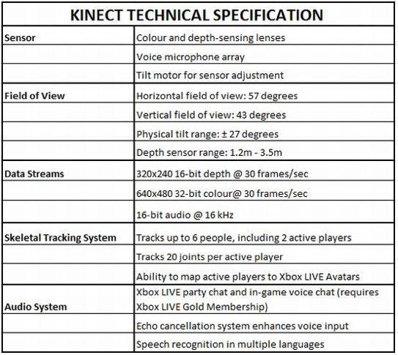

Table 2: Kinect Specifications

**2.3.2 FEATURE VECTORS AND NEURAL NETWORKS**

The previous literature emphasized the need for effective feature vectors that provide distinctive information to the neural network for classification. The design of the neural network also plays an important role in generating further features that go on to make the final classification. We used statistical measures to describe some important properties of our joint coordinates and eliminate redundancies.

The Statistical moments used were Mean, Variance, Skewness and Kurtosis. The mathematical formula to calculate the above is given below,

$$x=\frac{E[({x-μ)}^{n}]}{σ^{n}}$$

$$For n=1, the moment is called Mean \\ For n=2, the moment is called Variance \\ For n=3, the moment is called Skewness \\ For n=4,the moment is called Kurtosis$$

A graphical representation of the above parameters is shown clearly in Figure 2.

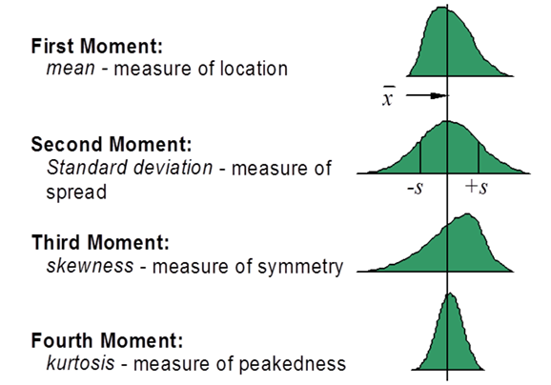

Figure 2: Central Moments

A brief outline of the Neural Network Architecture is shown below,

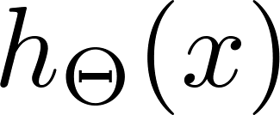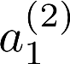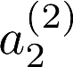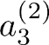

Figure 3: Neural Network Architecture

The above shown basic network model is 3 layered (the number of layers can vary depending on complexity) with input layer, hidden layer and output layer. The input layer is where the features are provided and output layer is where the decision is made as to what class the sample belongs to. The hidden layer is the most integral part of the network which determines a subset of features that help with the final classification. The network learns this hidden layer features over time as it is trained.

The cost function (which is a measure for the error between the actual output and the desired output averaged over all samples) for a Neural Network is,

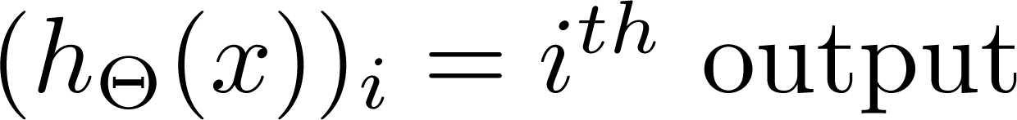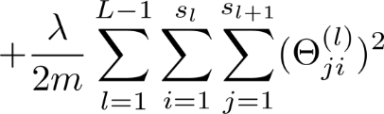

Where,

*L*= total number of layers in the network

*sl*= number of units (not counting bias unit) in layer *l*

*K*= number of output units/classes

The network works to minimize this cost function over multiple iterations. When a desired minimum cost function is achieved, the training phase is completed.

**2.3.3 ROC PLOTS**

A Receiver Operating Characteristic plot offers insight into the data and an accurate two metric representation that provides for better understanding than what the classification accuracy would provide. Figure 4 shows the Confusion plot that puts Predicted Condition (Predicted class) vs True condition (Actual class) into perspective. A ROC plots considers True Positive Rate/Recall on the y axis and the False Positive Rate/Fall-out on the x axis.

A ROC curve can be found in figure 5 with explanations of ideal conditions and worst case conditions outlined.

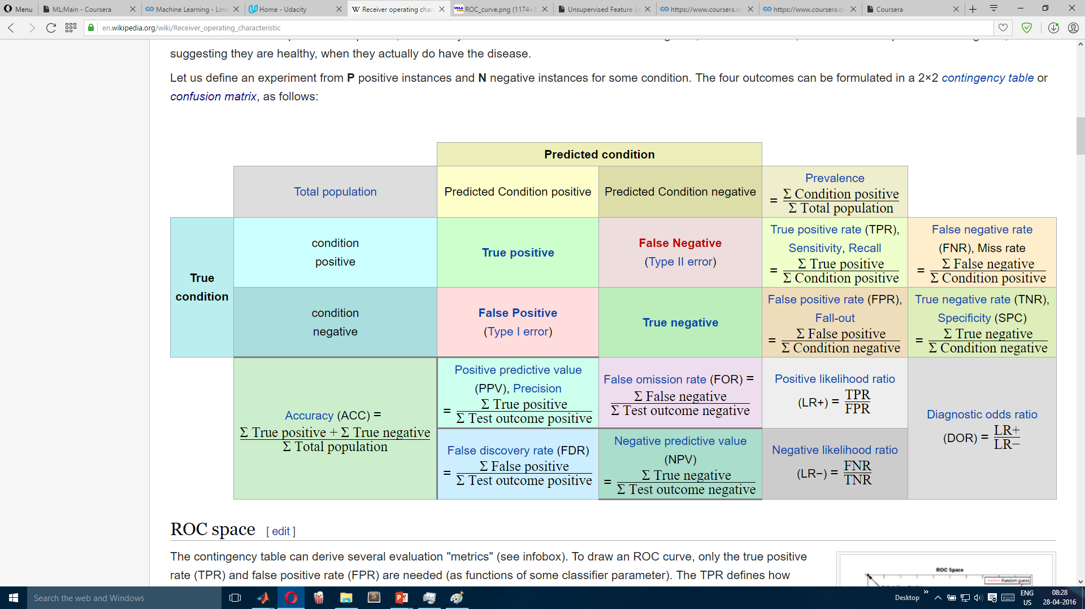

Figure 4: Confusion plot

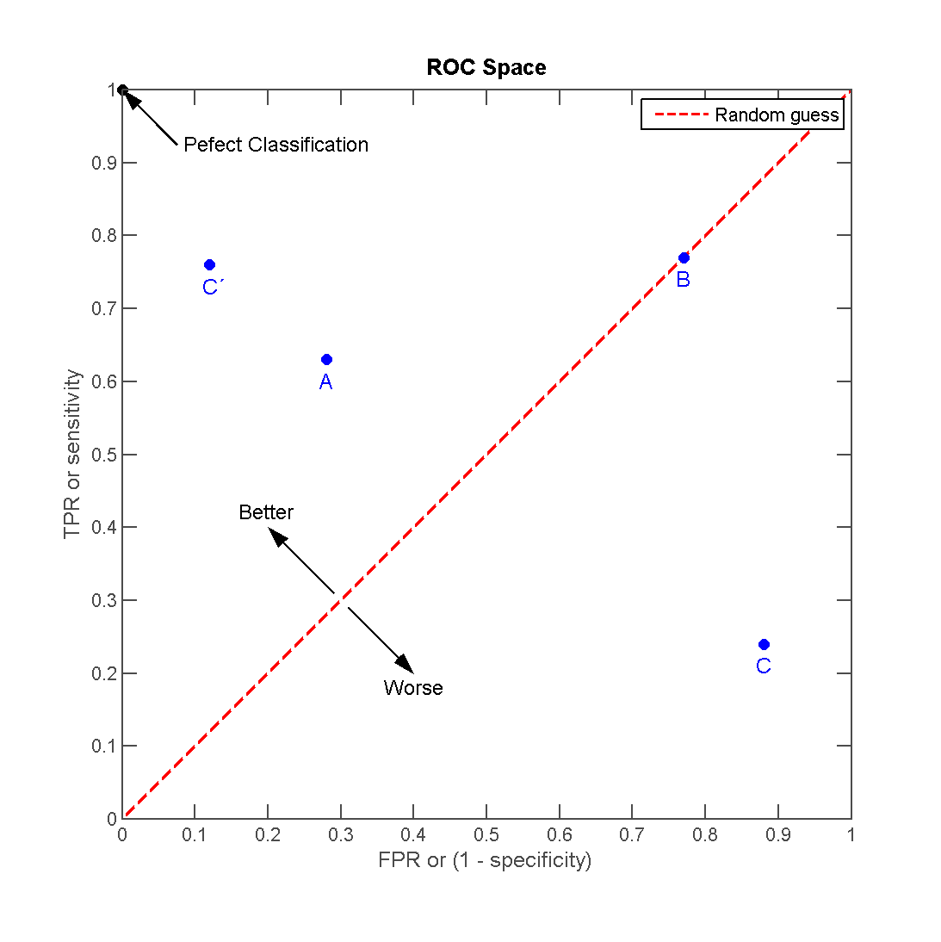

Figure 5: ROC Plot

**2.4 CONCLUSION**

This chapter gave a brief analysis of previous work and present proceedings in the field of research. An elaborate description of inferences made from each of these proceedings was outlined along with results from the same. The chapter then explained some of the theoretical data and mathematical relevance of concepts used further along the thesis.

**CHAPTER 3**

**METHODOLOGY**

This chapter includes a detailed description of the methodology and process flow followed to arrive at the final system. It explains the organization of the feature vectors, architecture of the neural network, model selection parameters and block diagrams that were essential in the research. Specifications of components and suitable explanations are also reviewed.

**3.1 DETAILED METHODOLOGY**

The research was split into 4 broad categories, (as represented in Figure 6)

1. Data Acquisition
2. Data Processing and Feature Extraction
3. Network Design
4. Optimization

**3.1.1 DATA ACQUISITION**

The data acquisition phase was the most critical part of the research. The amount of data extracted along with the quality of the data would play a huge role in how the system would respond to fresh data. The data was collected via the Microsoft Kinect with the Image Processing Toolbox available on MATLAB.

Indian Sign Language gestures of “Hello”, “Welcome” and “Good” were taken up for classification. Each of these gestures had distinct variations but also possessed minute similarities so that the classifier could truly be tested. These words were obtained from Mr. Arun.C.Rao’s videos on Sign Language Basics [6]. The Microsoft Kinect was used to capture video streams of gestures being performed with the RGB and Depth Cameras. Information was collected over 3 frames when movement was detected. The movement among these frames was averaged out and a final representation of the gesture was obtained. This representation comprised of 10 joints in a 3 dimensional plane. The whole process was automated and a total of 170 datasets were collected out of which 120 samples were used for network design. These 170 samples were collected with induced variations to accommodate worst case scenarios within the system. A total of 30 people contributed to this process which was done by conducting a survey in the MIT Campus that gave an insight on a person’s average knowhow of ISL along with the needed collection of datasets. This was necessary to ensure that the data sets were general and accounted for a person’s variation in height, weight and shape. The datasets also had various other variations incorporated into it.

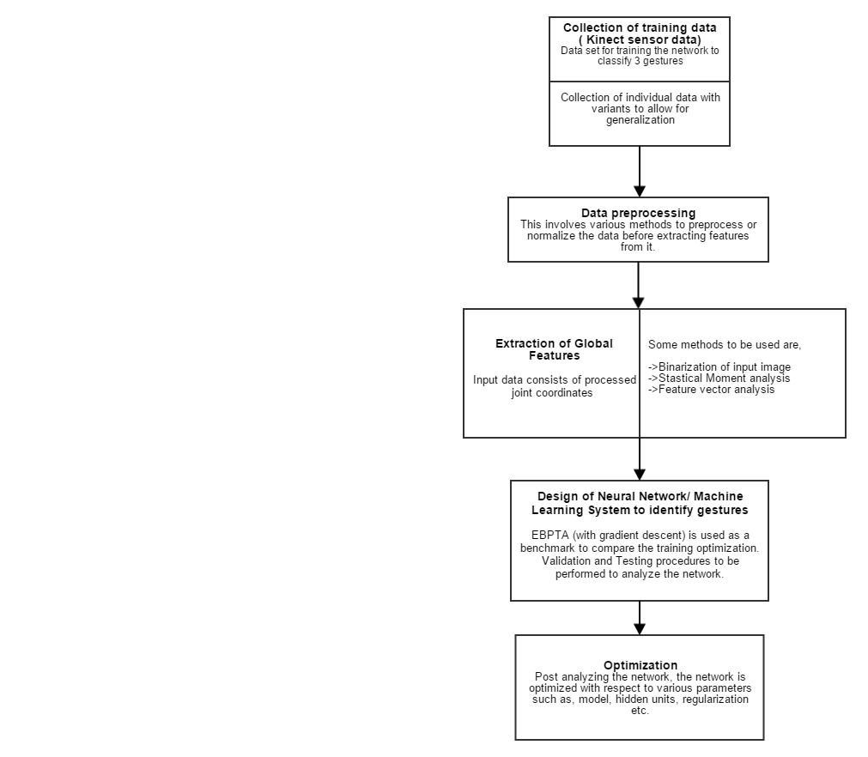

Figure 6: Work Flow

The factors under consideration were:

1. Distance from the sensor ( Over a range of 1.2-3m): The training data was collected over 3 different distances of 1.5m, 2m and 2.5m
2. Lighting Conditions: For every distance index, one image has been taken with contrasting lighting as compared to the other three.
3. Accounting for Obstacles: Images have been randomized with obstacles to obtain varied training data.
4. Gesture speed variation: Every gesture has been recorded with different time indices to maintain generalization.

After collection of 120 samples, semantics were gathered from the data set and a visual representation was derived. Figure 7 shows the joint numbers along with the joints that characterize the data collected over all the 3 frames. These joint numbers were then reordered from 1-10.

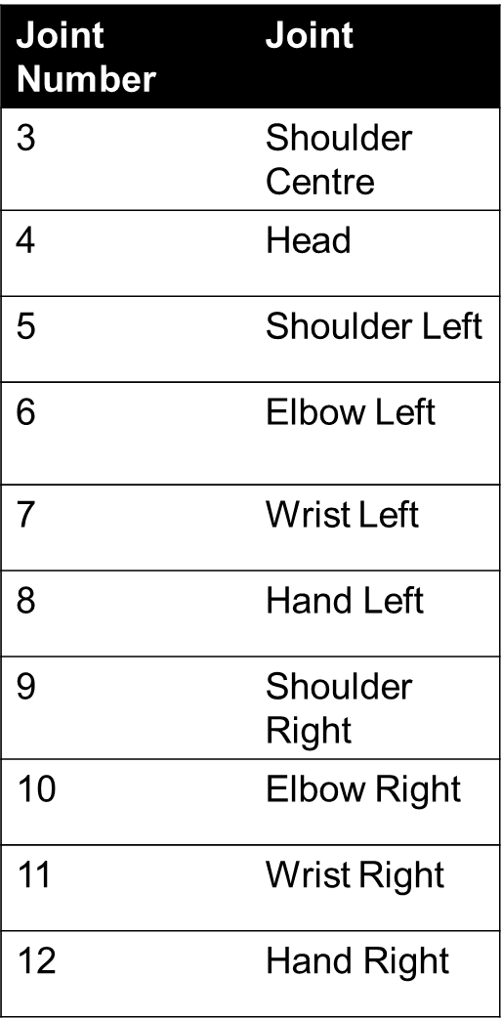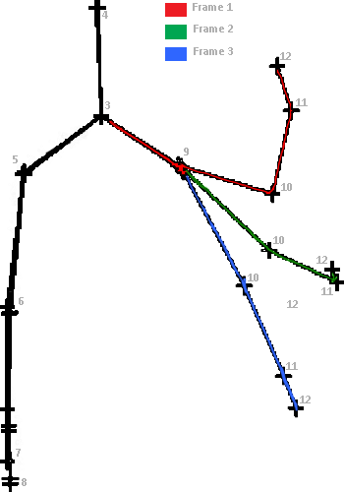

Figure 7: Joint Semantics

Figure 5 was generated by drawing a skeleton outline over the marked 3 dimensional joints by bringing them down to 2 dimensions and then binarizing the data.

**3.1.2 DATA PROCESSING AND FEATURE EXTRACTION**

3 different methods were used to generate features for training with the network model. Binarization was used initially to test the waters with the input data collected and to provide a base for comparison. The $(10,3)$ matrix of gesture coordinates was obtained from the data acquisition phase over 3 frames that characterized the motion. The coordinates were connected using a skeleton and this gave us a feature in 2 dimensions. The image was binary which had a marker value of 0 when the skeleton was present and of 1 when it was absent. Since this image varied in position for people with different heights and weights, it was normalized using the bounding box method to give uniformity over all data sets. Figure 8 shows the image after normalization. The image was then reduced to $256x256$ dimensions. This was our final feature for the Binary method.

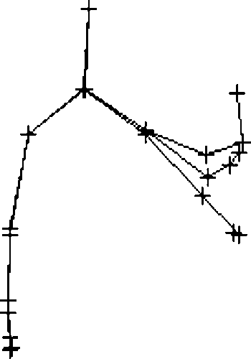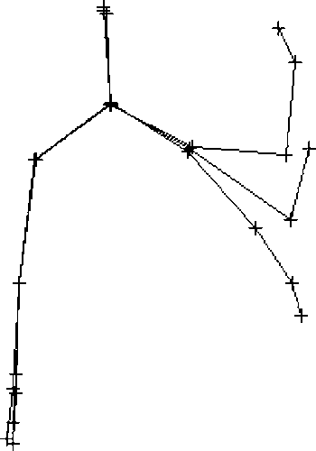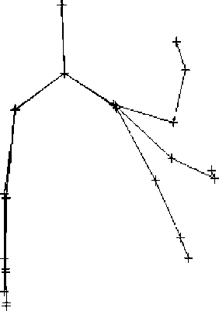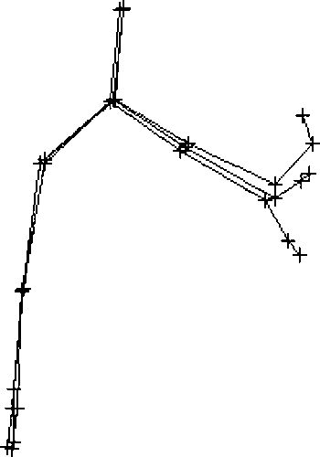

Figure 8: Binary feature vectors

The second method used for feature extraction was Statistical moment analysis. As explained under background theory; mean, variance, skewness and kurtosis were used to introspect the data and redundant information was dropped. This effectively reduced the dimensionality of the data saving time with computations. For each gesture, the mean value was found over all the samples and central moments were calculated with respect to each sample over all values. The data was observed for any underlying pattern or structure. It was found that certain joints had mean values lying very close to each other but other metrics such as variance, kurtosis and skewness lay far apart. Such trends were used as classification measures and helped in eliminating unnecessary data that made no contribution to the final result. Figure 7 shows the plot of all these values. The 3D plot for all the four moments can be found in the annexures. Joints 1, 2,3,7,8 were considered and the rest of the joints were discarded. The central moments difference (max-min) in values are shown below,

|  |  |  |  |  |
| --- | --- | --- | --- | --- |
| Joint Number | Mean | Variance | Skewness | Kurtosis |
| 1 | 0.2 | 0.4 | 1.8 | 1.5 |
| 2 | 0.2 | 0.3 | 1.6 | 1 |
| 3 | 0.2 | 0.3 | 1.6 | 1.2 |
| 7 | 0.2 | 0.3 | 1.4 | 1 |
| 8 | 0.15 | 0.2 | 0.8 | 0.8 |

Table 3: Central moments differences (max-min values along one of the axes)

These differences were used as metrics for generation of feature vectors. 4 central moments from 3 means belonging to each gesture over five joints gave us a total of,

$$5 joints x 3 dimensions=15 features \\ 15 features x 4 central moments=60 features \\ 60 features x 3 mean for each gesture=180 features$$

The last method involved using the gesture coordinates itself as features for training the system.

$$10 joints x 3 dimensions=30 features$$

This method involved taking 30 features.

**3.1.3 NETWORK DESIGN**

After the extraction and pre-processing of features in the binary image, we obtained a $256x256$ image. This image was then segmented and operated on with Block Processing Toolbox in MATLAB. The image was first split into $16$ blocks of $64x64$ pixels each. Each of these blocks were operated on separately and the final output was obtained by their combination. The Network involved a 2 stage structure. The first stage comprised of 16, 3 layered neural networks. The blocks were processed in parallel with the help of Parallel Computing Toolbox. The structure of a block is outlined in Figure 9.

The training algorithm used was Gradient Descent with Minimum square error as the performance measure. The network had a performance goal of 1e-5 and was run over 300 iterations.

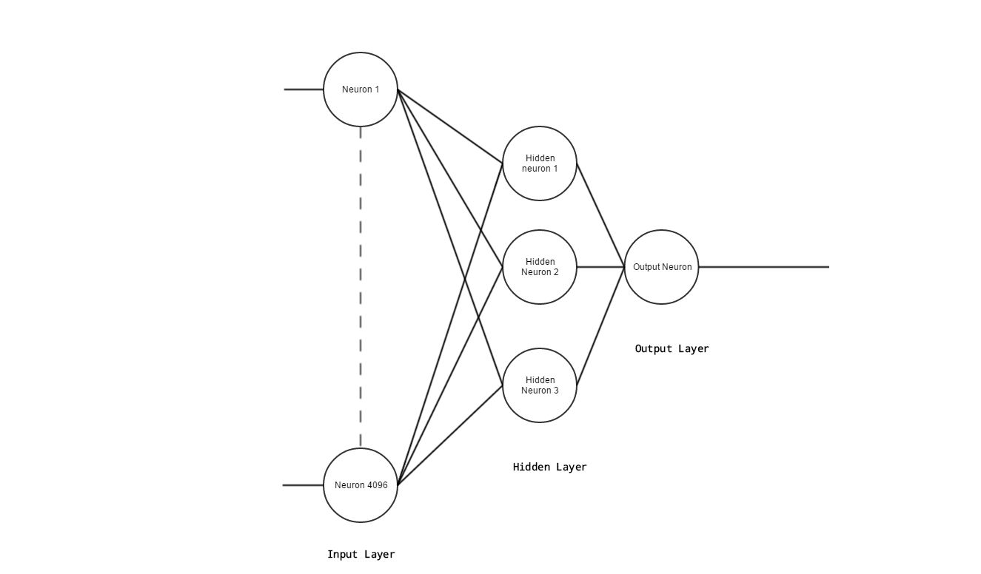

Figure 9: Network architecture for first stage

The input to the network was a 4096 element vector and a single output was obtained. This was repeated over 16 blocks and the output vectors of each were concatenated. This gave us a 16 element vector that was fed to the second stage of neural computation. The second stage was slightly more complex than the first stage as it involved majority of the decision making process and could not modify the first stage to rectify any error. This was one of the major drawbacks of the 2 stage network architecture. The second stage architecture is described in Figure 10. This second stage implementation described in the figure was initially taken as a standard. For further implementations of training algorithms, the number of hidden layers and hidden units within each layer were varied to give a better classification accuracy. Each variation of these parameters gave us a different classification, training and validation accuracy. Hidden units and hidden layers act as feature learners in a neural network allowing them to grasp unspecified features that contribute to output classification. More hidden units and layers add to the complexity of the system by adding more features.

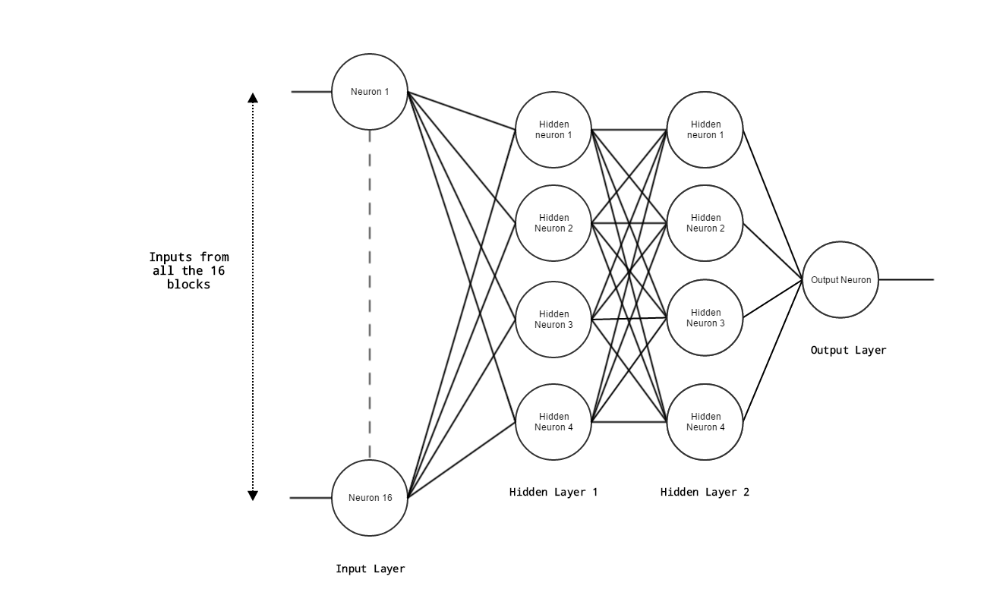

Figure 10: Second stage/ Final Architecture

The second stage of the network involved a variety of combinations. 5 different training algorithms were used with a different combination of hidden layer and unit.

The algorithms were,

1. *Gradient Descent:*

The weights and biases are updated in the direction of the negative gradient of the performance function. The performance function is expected to reach the global minima where the gradient is zero and no more updating of the parameters take place.

1. *Gradient Descent with Adaptive Momentum:*

Similar to the Gradient Descent but with an additional feature of momentum.

Function acts like a low-pass filter, adaptive momentum allows the network to ignore small features in the error surface.

1. *Gradient Descent with Adaptive Learning Rate and Momentum:*

This provided an addition of adaptive learning rate that reduced or increased the learning rate (step size in gradient descent) depending on previous values of the gradient.

1. *Levenberg-Marquardt Algorithm:*

Updates weight and bias values according to Levenberg-Marquardt optimization. This function uses the Jacobian for calculations, which assumes that performance is a mean or sum of squared errors.

1. *Scaled Conjugate Gradient:*

This method involved the comparison of the convergence of gradient descent in iterations with the conjugate vector (direction) to obtain a solution to linear system. Conjugate gradient, assuming exact arithmetic, converges in at most *n* steps where *n* is the size of the matrix of the system.

The second feature extraction method gave us 180 feature vectors and the 3rd method gave us 30. These vectors were similar and had a resolution of 4 decimal digits and were between the ranges $\left\{-1,+1\right\}$. These vectors were then fed to a neural network with the trial and error method that estimated a random value for number of hidden layers and number of hidden units.

For the 30 feature vector analysis, the Network architecture is shown in Figure 11. Some of the network parameters are,

|  |  |
| --- | --- |
| **Network Parameters** | **Attributes** |
| Training Algorithm | Gradient Descent with Adaptive Learning Rate and Momentum |
| Number of iterations | 100 |
| Training Accuracy | 98.8% |
| Validation Accuracy | 100% |
| Testing Accuracy | 94.4% |

Table 4: Network Parameters

The ROC plots for the Training, Validation and Test sets are also shown in Figure 11

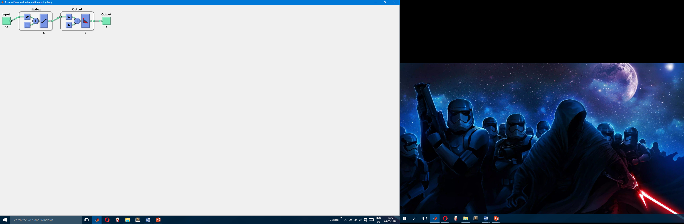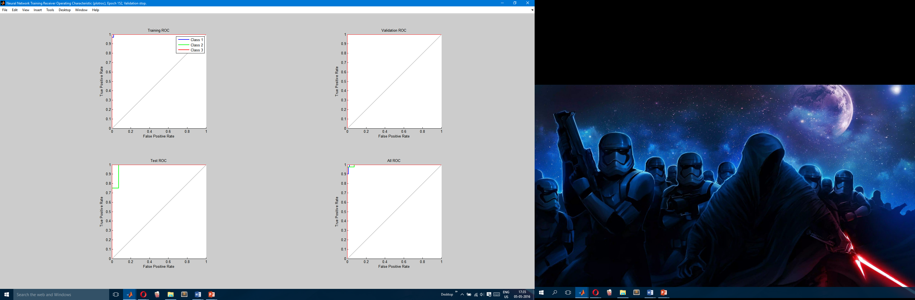

Figure 11: Network Parameters

These were some of the preliminary results obtained from the neural network design. A testing accuracy of 94.4 percent was obtained and needed to be optimized for better performance. A similar design was implemented for the Statistical Moment Analysis as shown in Figure 12. The learning parameters are described in Table 5.

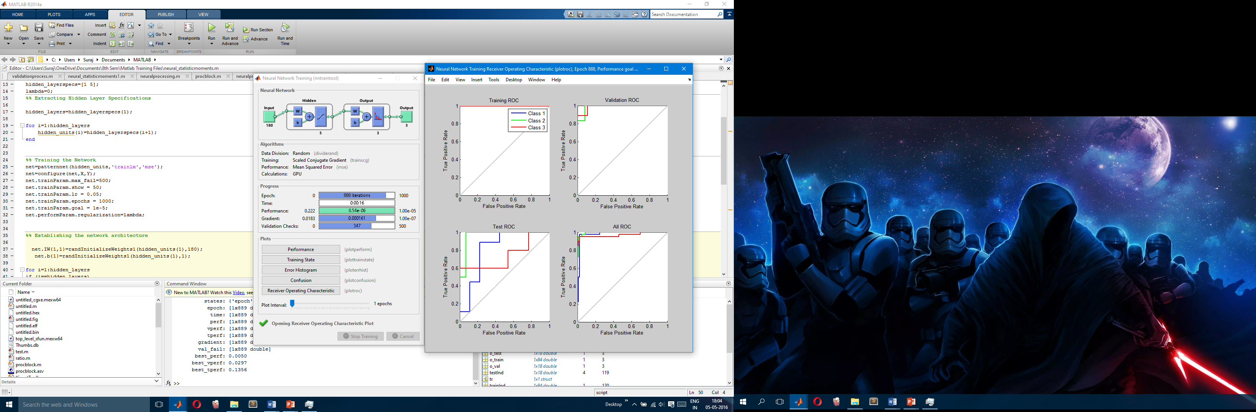

Figure 12: Network parameters

|  |  |
| --- | --- |
| **Network Parameters** | **Attributes** |
| Training Algorithm | Scaled Conjugate Gradient |
| Number of Iterations | 1000 |
| Training Accuracy | 100% |
| Validation Accuracy | 94.4% |
| Testing Accuracy | 77.8% |

Table 5: Network Parameters

*space for SVM*

**3.1.4 OPTIMIZATION**

After the network design phase was completed and preliminary results were obtained, we moved on to optimizing the network for best performance and classification. An array of factors and parameters were to be considered for optimization as the initial setup was purely based on trial and error methodology. The neural network was then checked for performance measures such as classification error and receiver operating characteristics to select the best pick. Some of the parameters considered were,

1. Model Selection (Regularization parameter)
2. Bias vs Variance
3. Hidden layers optimization
4. Hidden Unit optimization
5. Learning Rate optimization

All these optimizations are run by splitting the dataset into 3 parts- A training set, A validation set and a test set. The datasets are divided in a set ratio into these three (usually 60% training, 20% validation and 20% test.) The validation accuracy is used as a metric to choose the selected parameter. Iterations are run on the network varying each parameter one by one and the parameter combination that gives the best accuracy on the validations set is used as the ideal model parameter. The test set is then used on this to find the error introduced when an unseen dataset is given to the system.

1. Model Selection

The regularization parameter is multiplied to each of the weights belonging to all layers. This adds a penalty to the weights when they begin to get too close to the ideal solution. This is done to prevent overfitting or adapting too well to the training set. A low value of regularization leads to high overfitting or high variance. A high value leads to under fitting or high bias and provides bad accuracy on the training set as well. This optimization is performed by considering a comparison with validation accuracy. When the lambda parameter is low (high variance) the validation error is high and training error is very low. As lambda increases the validation decreases and training error increases slightly. As lambda goes very high, both errors go very high. The aim is to find an optimum value for lambda to minimize both the errors.

This chapter should include

* Introduction (1 paragraph brief of what is going to be discussed in this chapter)
* Methodology
* Detailed methodology
* Assumptions made
* Circuit layout / one-line / block diagrams
* Component specifications
* Justification for component selection
* Tools used
* Detailed specification / listing of the various components, measuring devices, software tool boxes, reference data sheets etc
* Preliminary result analysis if any
* Conclusions

**CHAPTER 4**

**RESULT ANALYSIS**

This chapter should include

* Introduction (1 paragraph brief of what is going to be discussed in this chapter)
* Result analysis
* Graphical / tabular form
* Explanation for the graphical / tabulated results
* Significance of the result obtained
* Any deviations from the expected results & its justification
* Conclusions

**CHAPTER 5**

**CONCLUSION AND FUTURE SCOPE OF WORK**

This chapter should include

* Brief summary of the work
* Problem statement / objective, in brief
* Work methodology adopted, in brief
* Conclusions
* General conclusions
* Significance of the results obtained
* Future scope of work.

(At least three paragraphs, one for each suggestion has to be written.)

# **REFERENCES**

*Web*

|  |  |
| --- | --- |
| [1] | Website, Official Microsoft, Introduction to Kinect. |
| [2] | J. Y. Y. Xu, “The Robotics Institute Carnegie Mellon University Pittsburgh, Pennslyvania”. |
| [3] | M. C. Saravanan, “Algorithm for face matching using normalized cross-correlation,” *International Journal of Engineering and Advanced Technology.* |
| [4] | R. Agarwal, “Hand Gesture recognition using discrete wavelet transform and support vector machine,” *Signal Processing and Integrated Networks ,* vol. 2nd, no. 2nd International Conference, p. 489, 2015. |
| [5] | M. C. U. P. a. H. R. Geetha M, “A Vision Based Dynamic Gesture Recognition of Indian Sign Language on Kinect based Depth Images,” Amrita School of Engineering, Kollam, Kerala, 2013. |
| [6] | M. Arun.C.Rao, “Sign Langauage Basics,” [Online]. Available: https://www.youtube.com/watch?v=6_u9ocF60gs. |

**ANNEXURES (optional)**

Annexure to include

* Product Data sheets
* Design drawings
* Standard diagrams
* Lengthy codes / algorithms etc

PROJECT DETAILS

|  |  |  |  |
| --- | --- | --- | --- |
| *Student Details* | | | |
| **Student Name** |  | | |
| Register Number |  | Section / Roll No |  |
| Email Address |  | Phone No (M) |  |
| **Student Name** |  | | |
| Register Number |  | Section / Roll No |  |
| Email Address |  | Phone No (M) |  |
|  | | | |
| *Project Details* | | | |
| **Project Title** |  | | |
| Project Duration |  | Date of reporting |  |
|  |  | | |
| *Organization Details* | | | |
| **Organization Name** |  | | |
| Full postal address with pin code |  | | |
| Website address |  | | |
|  |  | | |
| *Supervisor Details* | | | |
| **Supervisor Name** |  | | |
| Designation |  | | |
| Full contact address with pin code |  | | |
| Email address |  | Phone No (M) |  |
|  |  | | |
| *Internal Guide Details* | | | |
| **Faculty Name** |  | | |
| Full contact address with pin code | Dept of E & C Engg, Manipal Institute of Technology, Manipal – 576 104 (Karnataka State), INDIA | | |
| Email address |  | | |

**General Guidelines (Delete this page when making the report submission)**

* Project Report to be minimum 40 pages. Reports less than 40 pages will be rejected
* Project report to be maximum 50 - 60 pages (preferred)
* Paper Size: A4; Left = Right = Top = Bottom Margins = 1”
* Page Numbering Position: Bottom with right justified and continuous numbering from the Introduction Chapter
* Use Times New Roman Font with Normal Style, paragraph justified and 1.25 line spacing
* Paragraph Heading: Times New Roman Font, Bold, Font Size 14; Paragraph Matter: Times New Roman Font, Normal, Font Size 12;
* Sub-paragraphs be appropriately numbered as in 1.1, 1.2, 1.3 etc; Sub-paragraph Heading: Times New Roman Font, Italics, Font Size 12; Sub-paragraph Matter: Times New Roman Font, Normal, Font Size 12;
* Figure captions below Figure with chapter wise numbering
* Tables captions above Table with chapter wise numbering
* All references must be quoted in ascending order (follow IEEE format for referencing)
* Project Details page must be the last page in the project report
* Only Soft bound reports will be accepted. The outer cover of the report will be **PURE WHITE** with a 170 GSM paper.

* **Arrangement of contents**

[1] Cover page (same as inner page)

[2] Inner page

[3] Dedication (Optional)

[4] Certificate

[5] Certificate on company letter head

[6] Acknowledgement

[7] Abstract

[8] List of Tables

[9] List of Figures

[10] Table of contents

[11] Chapters 1, 2, 3, 4, 5

[12] References (follow IEEE format)

[13] Annexures

[14] Project Details (Last page of the report)

* The above guidelines should be used only as a help guide and is more or less a standard way of report writing
* Report formatting should not be disturbed in any form
* **Project students are requested to discuss with their department guides regarding the contents of the project report**
* Hard Copies to be prepared: 3 (1 individual copy, 1 each for guide & dept.)
* Soft copy (both word and pdf format) to be submitted in PG LAB,with project name as filename.